PRACTICAL NO:-1

1. Configure Routers:
Diagram:-
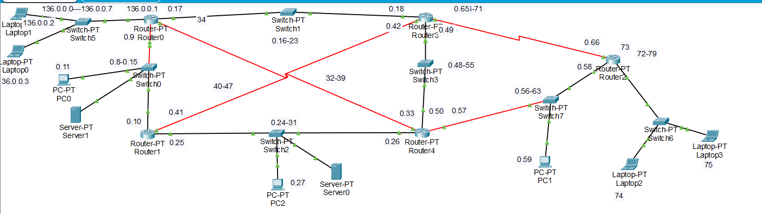
Addressing Table:-
Device | Interface | IP Address | Subnet Mask | Default Gateway | Switch Port
Router0 | Fa0/0 | 136.0.0.1 | 255.255.255.248 | N/A | N/A
Router0 | Fa1/0 | 136.0.0.17 | 255.255.255.248 | N/A | N/A
Router0 | Serial2/0 | 136.0.0.34 | 255.255.255.248qa | N/A | N/A
Router0 | Fa4/0 | 136.0.0.9 | 255.255.255.248 | N/A | N/A
Router1 | Fa0/0 | 136.0.0.10 | 255.255.255.248 | N/A | N/A
Router1 | Fa1/0 | 136.0.0.25 | 255.255.255.248 | N/A | N/A
Router1 | Serial2/0 | 136.0.0.41 | 255.255.255.248 | N/A | N/A
Router2 | Fa0/0 | 136.0.0.58 | 255.255.255.248 | N/A | N/A
Router2 | Fa1/0 | 136.0.0.73 | 255.255.255.248 | N/A | N/A
Router2 | Serial2/0 | 136.0.0.66 | 255.255.255.248 | N/A | N/A
Router3 | Fa0/0 | 136.0.0.18 | 255.255.255.248 | N/A | N/A
Router3 | Fa1/0 | 136.0.0.49 | 255.255.255.248 | N/A | N/A
Router3 | Serial2/0 | 136.0.0.65 | 255.255.255.248 | N/A | N/A
Router3 | Serial3/0 | 136.0.0.42 | 255.255.255.248 | N/A | N/A
Router4 | Fa0/0 | 136.0.0.26 | 255.255.255.248 | N/A | N/A
Router4 | Fa1/0 | 136.0.0.50 | 255.255.255.248 | N/A | N/A
Router4 | Serial2/0 | 136.0.0.33 | 255.255.255.248 | N/A | N/A
Router4 | Fa4/0 | 136.0.0.57 | 255.255.255.248 | N/A | N/A
PC0 | Fa0 | 136.0.0.11 | 255.255.255.248 | 136.0.0.9 | Switch0
PC1 | Fa0 | 136.0.0.59 | 255.255.255.248 | 136.0.0.57 | Switch7
PC2 | Fa0 | 136.0.0.27 | 255.255.255.248 | 136.0.0.25 | Switch2
Laptop0 | Fa0 | 136.0.0.3 | 255.255.248.0 | 136.0.0.1 | Switch5
Laptop1 | Fa0 | 136.0.0.2 | 255.255.255.248 | 136.0.0.1 | Switch5
Laptop2 | Fa0 | 136.0.0.74 | 255.255.255.248 | 136.0.0.73 | Switch6
Laptop3 | Fa0 | 136.0.0.75 | 255.255.255.248 | 136.0.0.73 | Switch6
Server0 | Fa0 | 136.0.0.30 | 255.255.255.248 | (Not Set) | Switch2
Server1 | Fa0 | 136.0.0.14 | 255.255.255.248 | (Not Set) | Switch0

Assigning IP to the router (CLI):-
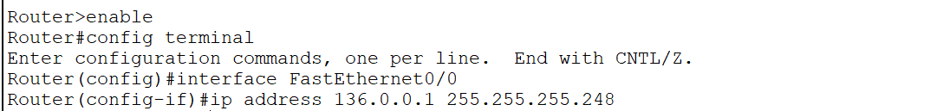
Assigning ospf to the router:-
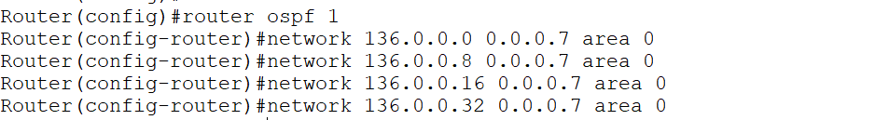
Same way assign to all router’s connected networks to the in ospf.

Now checking the established connection:-
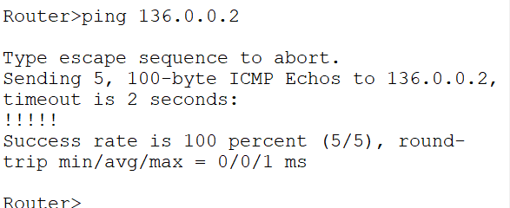
Checking IP route:-
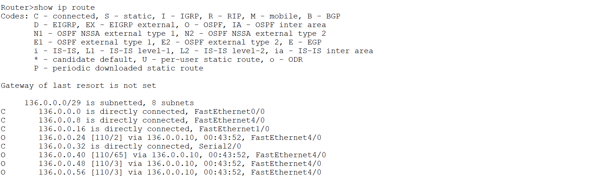

a. OSPF MD5 authentication.

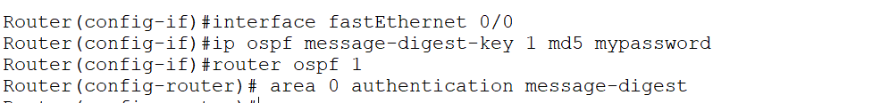
Assigning these to all interfaces of each router.
All routers in the same OSPF link must use:
- Same key number
- Same password
- MD5 enabled on both ends
Checking whether the md5 authentication is applied or not:-
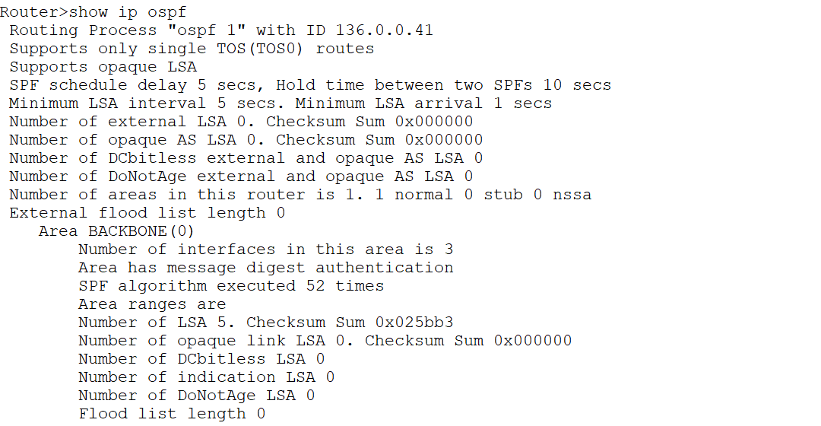
We can confirm it by checking below output where key id is defined and authentication is enabled.
Router>show ip ospf interface

FastEthernet0/0 is up, line protocol is up
Internet address is 136.0.0.10/29, Area 0
Process ID 1, Router ID 136.0.0.41, Network Type BROADCAST, Cost: 1
Transmit Delay is 1 sec, State DR, Priority 1
Designated Router (ID) 136.0.0.41, Interface address 136.0.0.10
Backup Designated Router (ID) 136.0.0.34, Interface address 136.0.0.9
Timer intervals configured, Hello 10, Dead 40, Wait 40, Retransmit 5
Hello due in 00:00:05
Index 1/1, flood queue length 0
Next 0x0(0)/0x0(0)
Last flood scan length is 1, maximum is 1
Last flood scan time is 0 msec, maximum is 0 msec
Neighbor Count is 1, Adjacent neighbor count is 1
Adjacent with neighbor 136.0.0.34 (Backup Designated Router)
Suppress hello for 0 neighbor(s)
Message digest authentication enabled
Youngest key id is 1
FastEthernet1/0 is up, line protocol is up
Internet address is 136.0.0.25/29, Area 0
Process ID 1, Router ID 136.0.0.41, Network Type BROADCAST, Cost: 1
Transmit Delay is 1 sec, State BDR, Priority 1
Designated Router (ID) 136.0.0.57, Interface address 136.0.0.26
Backup Designated Router (ID) 136.0.0.41, Interface address 136.0.0.25
Timer intervals configured, Hello 10, Dead 40, Wait 40, Retransmit 5
Hello due in 00:00:05
Index 2/2, flood queue length 0
Next 0x0(0)/0x0(0)
Last flood scan length is 1, maximum is 1
Last flood scan time is 0 msec, maximum is 0 msec
Neighbor Count is 1, Adjacent neighbor count is 1
Adjacent with neighbor 136.0.0.57 (Designated Router)
Suppress hello for 0 neighbor(s)
Message digest authentication enabled
Youngest key id is 1
Serial2/0 is up, line protocol is up
Internet address is 136.0.0.41/29, Area 0
Process ID 1, Router ID 136.0.0.41, Network Type POINT-TO-POINT, Cost: 64
Transmit Delay is 1 sec, State POINT-TO-POINT,
Timer intervals configured, Hello 10, Dead 40, Wait 40, Retransmit 5
Hello due in 00:00:05
Index 3/3, flood queue length 0
Next 0x0(0)/0x0(0)
Last flood scan length is 1, maximum is 1
Last flood scan time is 0 msec, maximum is 0 msec
Suppress hello for 0 neighbor(s)
Message digest authentication enabled
Youngest key id is 1

b. NTP.
Here we defined a ntp server which will provide times to other routers and add it to any network and also assign default gateway as well .
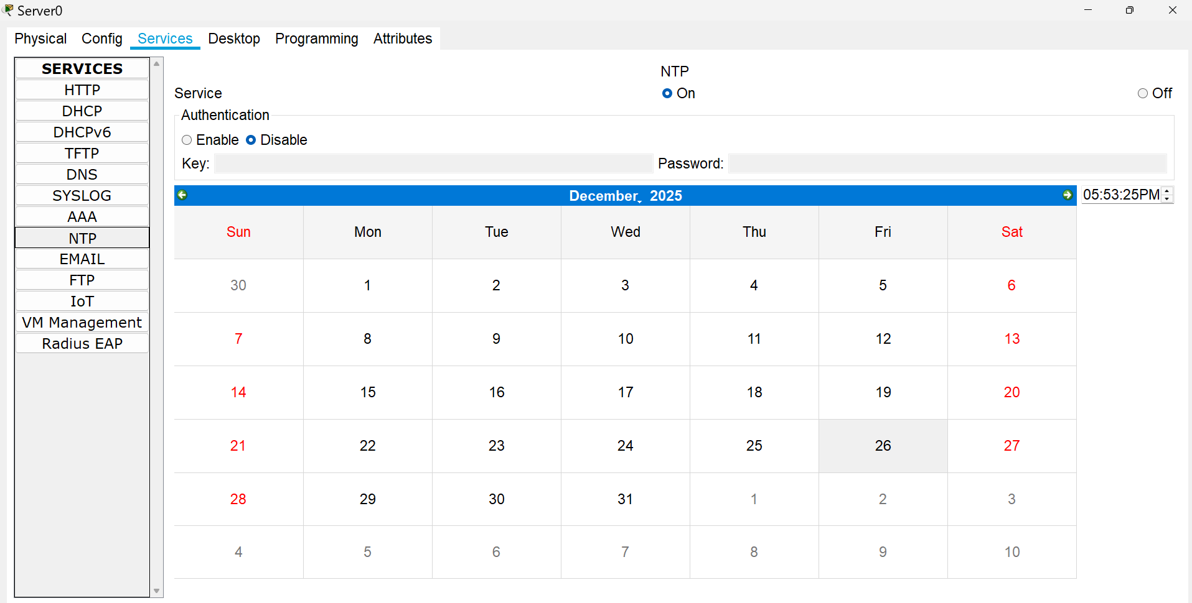
Now set ntp server as a date provider for routers.
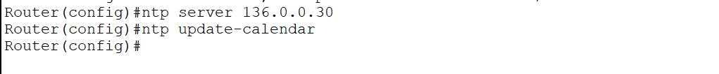
Now assign each router with ntp server.
Then checking time on routers.
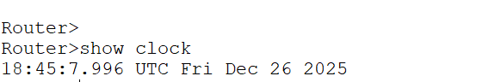

c. to log messages to the syslog server.
First enable syslog server as below:
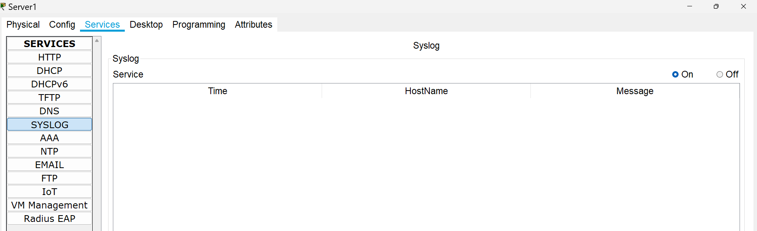
Now we will assign syslog server ip to the router to maintain logs.
As below:-
Now we will use commands to check whether the logs are stored or not.

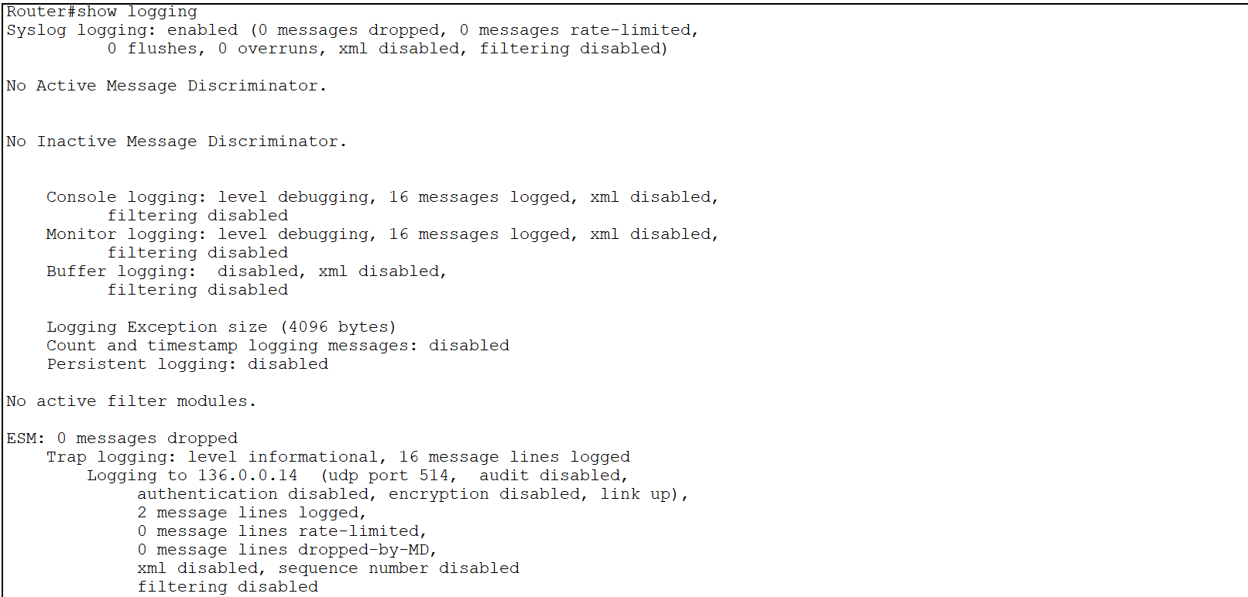

We can also check on syslog server logs to check logs.
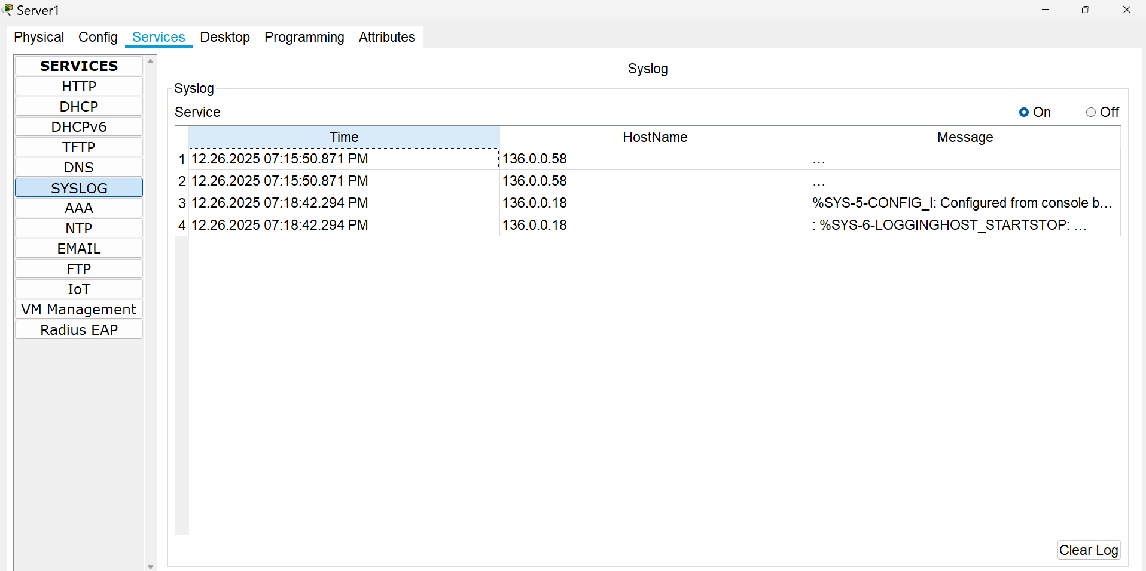

Accessing router through Telnet:-
First you have to configure router:-
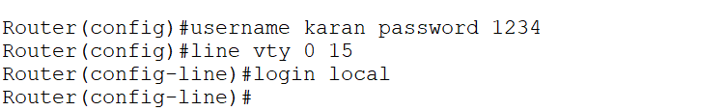
It will allow us to access any user of router through cli using login local.Otherwise normal user access will be granted.
Now from pc we will try to access router.
